VERSION HISTORY
VER. | VERSION DETAIL/S | AUTHORED BY: | APPROVED BY: | DATE APPROVED
1.0 | Agreed and SIGNED OFF Guidelines | Indra | Globe ISG | 12/20/2019

DOCUMENT UPDATE HANDLING

The RPA CoE Core team will have a quarterly cadence in order to evolve the documents and to improve the guidelines based on the experiences from previous quarter. The document will have the same people assigned to review and sign-off. In case there are changes in the approvers, the new person assigned to review and update the document must be listed in the version control table of the document

Table of Contents
1. Introduction 3
1.1. Purpose 3
1.2. Scope 3
1.3. Audience 3
1.4. Glossary 3
1.5. Tools 4
2. Compliance to Standards 5
2.1. Methodology 5
2.2. Data Privacy Act of 2012 6
2.3. PCI DSS (Payment Card Industry Data Security standard) 6
3. Current Globe Procedures 7
3.1. Security Risk Assessment 7
3.2. Accesses and Credentials Provision 9
4. Recommended Procedures 11
4.1. Partial Security Risk Assessment 11
5. Security Roadmap 12

Introduction
  - Purpose
The purpose of this document is to compile the global security framework and convert it into instructions and criteria for the implementation and operation of RPA (Robotic Process Automation) environments in Globes assets.
Compliance with the compiled guidelines will give the organization a global vision of the security of the assets of the organization, and guarantee the confidentiality, integrity and availability of the information, so that the data is protected at all times, thus guaranteeing the security of the information of the organization.
In addition, given that the operation of these RPA is often unattended or completely automated, the traceability of the operations made by this type of software must be ensured, so that it can be reviewed how, where and by whom each of them has done the actions.
  - Scope
This document has a transversal scope, involving all assets, both those managed by Globe and external suppliers, which include applications, hosts, network devices, mobile apps and others. In the case of being managed by external suppliers, they have to guarantee compliance with all the requirements and procedures established in the document.
  - Audience
This document is directed to the following roles:
- Mandatory:
  - RPA SDM/ DevOps Coach
  - Solution Designer
  - DevOps Engineer
  - Infra Squad
  - Security SME
  - Developer Lead
- Recommended:
  - Product Owner
  - Developers
  - Testers
  - Glossary
PDD | Process Definition Document
SDD | Solution Definition Document
ODH | Operation and Deployment Handbook
Security SME | Security Subject Matter Expert
TBD | To be defined
VMI | Virtual Machine Image

  - Tools
The set of tools for which the methodology defined in this document applies and should be used as automation tools for robotic processes and data processing are the following:
- UiPath v2018.4

Compliance to Standards
  - Methodology
For the context of this chapter, the following stages in data processing cycle are considered:
For the context of this document, storage is defined as the permanent retention of data, making it accessible for future indefinite use.
During RPA processes, customer data should never be stored (stage 6) in any component, that is part of the RPA solution. For other types of non-customer data that are part of the RPA process this restrictions do not apply.
For example:
Data | Classification
Specific customer’s billing plan | Customer data
Number of customers per billing plan | Non customer data
Credentials to applications | Non customer data

Therefore:
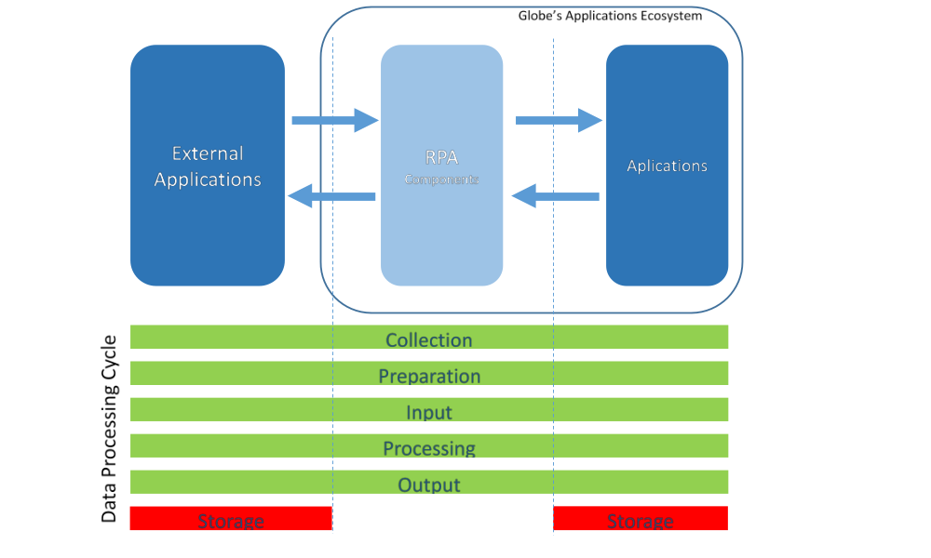
This can be achieved by never storing (i.e. in execution logs, files, etc.) any customer data during any part of the RPA process. In the case it is essential to store the data during the process execution (i.e. in queues), guaranty that the stored data is no longer stored in any RPA component by the end of the process.
  - Data Privacy Act of 2012
“The Data Privacy Act of 2012, requires organizations to make their data processing transparent to their customers, and maintain the confidentiality, integrity and availability of their data.”
This can be guaranteed if the set of guidelines defined in the RPA CoE are followed.
The processing of their data can be made transparent using the documentation that describes each process in production (PDD, SDD and ODH).
The guarantee of confidentiality, integrity and availability of the data is provided by not storing any data in the RPA components, passing that responsibility to the applications used in the process, effectively making those obligations Business As Usual from RPA’s point of view.

  - PCI DSS (Payment Card Industry Data Security standard)
All developments should follow Globe’s current policy on this matter and a security SME should be involved for consultation for the development of every process that involves this kind of data.

Current Globe Procedures
  - Security Risk Assessment
The Security Risk Assessment is a procedure executed by Globe’s security team, as follows:
Prerequisites:
Security SME available and attributed to the project under assessment.
Execution:
- Security Design Review
Infrastructure Squad provides the following information to the Security SME.
-Tec Rec document of the generic virtual machine image
-Identification of the resources to be evaluated.

- Assessment
Executed by the Security SME. Gathering of asset details (IP addresses, O.S., etc.) filing the Security Risk Assessment Template.
- Perform Security Scanning
Executed by the Security SME. Security agents are installed and executed, producing a Vulnerability Assessment Report on the following items:
  - OS Hardening
  - DB Hardening
  - Web Hardening
  - Network Element Segmentation
  - Traffic Segmentation
  - Layer 4 Controls
  - Secure Network Protocols
  - Physical Security
  - Backup
  - Resilience
  - Testbed
  - Secure Coding – May not by applicable for RPA, due to unavailability of automatic code analysis tools for UiPath components
  - API Security Building Blocks
  - Security Audit Logs
  - Data Type Inventory
  - Encryption of Stored Confidential Information
  - Encryption of Transmitted Confidential Information
  - Access to Data
  - Security over Credit Card Information
  - Globe Password Control
  - Role Based Access (RBA)
  - Integration to Privilege Access Management (PAM)
  - Multi-Factor Authentication
  - Integration to Active Directory (AD)
  - Integration to Oracle Virtual Directory (OVD)
  - Self-Service Password Reset
  - Data Protection by Third Parties
  - Data Protection by Platforms
  - AWS Security
  - Web application (if involved)

- Correction of the Identified Vulnerabilities

By Globe’s definition, the correction of the vulnerabilities identified during the Security Risk Assessment is responsibility of the project team, in this case the RPA CoE team.

The following table show the proposed roles that will be responsible for correcting the identified vulnerabilities.

Vulnerability | Current State | End State
a. OS Hardening | Infra Operations | Infra Squad
b. DB Hardening | Infra Operations | Infra Squad
c. Web Hardening | Infra Operations | Infra Squad
d. Network Element Segmentation | Infra Operations | Infra Squad
e. Traffic Segmentation | Infra Operations | Infra Squad
f. Layer 4 Controls | Infra Operations | Infra Squad
g. Secure Network Protocols | Infra Operations | Infra Squad
h. Physical Security | Infra Operations | Infra Squad
i. Backup | Infra Operations | Infra Squad
j. Resilience | Infra Operations | Infra Squad
k. Testbed | Infra Operations | Tester
l. Secure Coding | N/A | N/A
m. API Security Building Blocks | Infra Operations | Infra Squad
n. Security Audit Logs | Infra Operations | Infra Squad
o. Data Type Inventory | TBD | TBD
p. Encryption of Stored Confidential Information | Code Related:  - RPA Lead Developer  Infrastructure Related:  - Infra Operation | Code Related:  - RPA Lead Developer  Infrastructure Related:  - Infra Squad
q. Encryption of Transmitted Confidential Information | Code Related:  - RPA Lead Developer  Infrastructure Related:  - Infra Operation | Code Related:  - RPA Lead Developer  Infrastructure Related:  - Infra Squad
r. Access to Data | Code Related:  - RPA Lead Developer  Infrastructure Related:  - Infra Operation | Code Related:  - RPA Lead Developer  Infrastructure Related:  - Infra Squad
s. Security over Credit Card Information | Code Related:  - RPA Lead Developer  Infrastructure Related:  - Infra Operation | Code Related:  - RPA Lead Developer  Infrastructure Related:  - Infra Squad
t. Globe Password Control | Code Related:  - RPA Lead Developer  Infrastructure Related:  - Infra Operation | Code Related:  - RPA Lead Developer  Infrastructure Related:  - Infra Squad
u. Role Based Access (RBA) | Infra Operation | Infra Squad
v. Integration to Privilege Access Management (PAM) | Infra Operation | Infra Squad
w. Multi-Factor Authentication | Infra Operation | Infra Squad
x. Integration to Active Directory (AD) | Infra Operation | Infra Squad
y. Integration to Oracle Virtual Directory (OVD) | Infra Operation | Infra Squad
z. Self-Service Password Reset | TBD | TBD
aa. Data Protection by Third Parties | TBD | TBD
bb. Data Protection by Platforms | Infra Operation | Infra Squad
cc. AWS Security | Infra Operation | Infra Squad
dd. Web application (if involved) | Infra Operation | Infra Squad

(Please refer to the infrastructure document for more details on the current and end state regarding the Infrastructure teams)

  - Accesses and Credentials Provision
During the RPA program, the creation/modification/deactivation of user accesses for the developers and robots will be a constant need. This chapter details on how to perform these requests in order to make them as transparent as possible.
In the RPA CoE the role responsible for performing these requests for all processes in productions is the RPA Operations team, for all other processes the responsible is the assigned Solution Designer for the specific process.
The User Access Managements (UAM) are classified into:
- access creation/modification/extension; network/email access reset/unlock; system/tool access reset/unlock, responsibility of ISG-ITSMO-STCM-SAQC;
- access deactivation of offboarding/transfer resource; and access deactivation of fraudulent account responsibility of ISG-IPS-VIAMIAM.
For any of the previous categories the request are done should be done using Globe’s ITSM application (Remedy) creating ticket at https://myglobeitservices.my.salesforce.com/
According to the following procedures:
- Access management already handed-over to IAM:
- Create ticket remedy IAM
- Receive email from IAM
- Answer with following template filled
Field | Data Type | Value
User ID | [a-z] | vjethani
Complete Company* (NO abbreviation allowed) | [a-z] | Globe
Cost Center* | [a-z] | ISG
Last Name* | [a-z] | Jethani
First Name* | [a-z] | Vishal
MI* | [a-z] | Raju
Title/Position | [a-z] | RPA Lead
Immediate Superior ID* | [a-z] | Jake
Office Location* | [a-z] | Eco Tower
Telephone Number* | +63 ########
Mobile Number* | +63 ######## | +639028465916
Expiry Date* | mm/dd/yyyy | 24/10/2019
Account Description: (OUTSOURCE-Vendor Employee, OUTSOURCE-Managed Services , OUTSOURCE-MS Prime)* | [a-z] | OUTSOURCE - Managed Services
Globe email access?* | Y / N | Y
Purpose of the Email access | [a-z] | Official
- Access management for application not handed-over to IAM:
- Create ticket remedy to service desk, and they will rout it
- Receive email from other team requesting from approval
Access Type | Handler | Approver
Server access T1 accounts | IAM OPS | First: Security  Final: IAM
Robot Globe Network IDs (for all applications that required Globe network ID to login) | IAM OPS | First: Security  Final: IAM
Robot Mailbox | IAM OPS | First: Security  Final: IAM
Access to production VMs | IAM OPS | First: Security  Final: IAM
Access for all other applications not yet turned over to IAM | L1 Service desk | Security

Recommended Procedures
  - Partial Security Risk Assessment
When creating new virtual machines, a generic virtual machine image (VMI) is used initially, which might require some process specific configurations, namely:
- Installations of applications
- Access to web applications
- Configuration of Operative System (Screen resolution, etc.).
Any changes in the already approved generic VMI, may result in Security Risk, for this it is recommended to execute a Security Risk Assessment prior to liberation of the new to the production environment.
In order to achieve a faster and more agile procedure it is recommended that for changes in a previously approved VMI, a Partial Security Risk Assessment to be executed, evaluating only the vulnerabilities that might have been impacted by the new configuration.
The Solution Designer, following the same steps already identified but additionally providing a detailed list of the new configurations, should do the request for this procedure.

Security Roadmap
The Security roadmap defines when Globe’s security procedures should be used each phase of the RPA program.
The following chart cover all the RPA Program from its Setup until long-term execution. The green spheres identify the need for a security procedure.
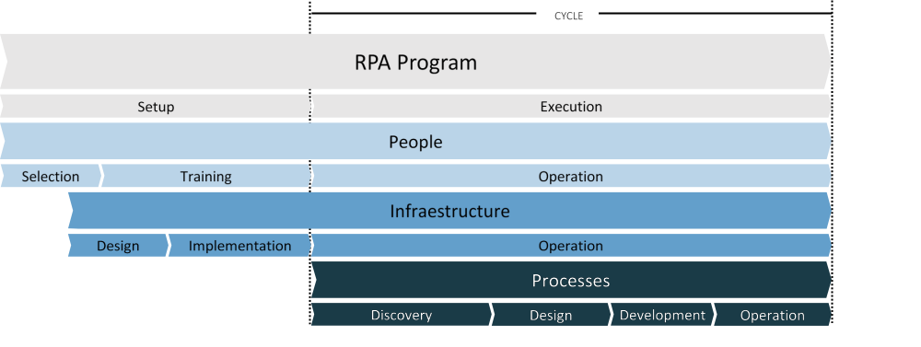

- Technical Meetings – During the periodic technical meetings where current technological solution is evaluated and improvements discussed and suggested. A Security Risk Assessment should be done to both current state solution and future. Security SME needed
- Human resources onboarding – During the onboarding to the RPA CoE an Access and Credentials provision should be done.
- Infrastructure Design – A Security SME should be consulted, to guarantee compliance.
- Process Discovery – Before process discovery an Access and Credentials provision must be done to provide the developer access to the applications or systems involved in the process.
- Process Development – After a process is sent for development, an Access and Credentials provision should be also schedule in order to provide the accesses and credentials for the robot to enter production.
- Process Deployment – Prior to deployment of a process to production, the VM were the process will execute, should be checked by the the Security SME following a requested Partial Security Risk Assessment in order to guarantee that, despite the changes that may have occurred to the initial standard VM image, the machine configuration is compliant with security standards.

